**Drama House Residency Application Fall 2012**

Contact our Logistics Officer at [*ecohen9@u.rochester.edu*](mailto:ecohen9@u.rochester.edu), with questions or concerns. Submit completed applications to the folder inside the front entrance of Drama House.

Name: Class Year: Phone:

Email: Current Room Assignment:

CPU Box:

Preferred Roommate (if known):_____________________________________________



2) Why do you want to live in Drama House?

3) Please add a caption to the illustration below:

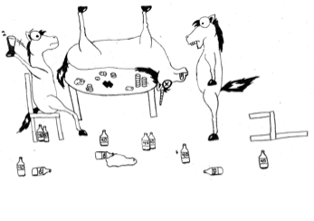

4) If you had to live with three historical figures, who would they be (in preference order), and why?

5) If you had ONE free hour to yourself with no commitments, what would you do?

6) What are some ideas/themes that you would like to see in either yours or other

members’ house projects?

7) Describe what you see in the blotches below.

